Client | [Customer Name will be written here]
Project Name | [Project Name will be written here]

Table of Contents
1 Document Overview 3
1.1 Scope & Purpose 3
1.2 Version Numbers 3
1.3 Audience 3
1.4 Document Structure and Special Conventions 3
1.5 Definitions, Symbols and Abbreviations 4
1.5.1 Definitions & Terminology 4
1.5.2 Abbreviations 4
1.6 References 5
2 Overall Design Considerations 6
2.1 Assumptions 6
2.2 Prerequisites, Restrictions and Constraints 6
2.3 Design Methodology 6
2.4 Open Issues and Risks 7
3 High Level Architecture 8
3.1 [Database Domain Name] 9
3.2 [Domain-Name 1] 9
3.3 [Domain-Name2] 9
3.4 [Domain-Name n] 9
4 Low Level Architecture 10
4.1 Application, Component, or Module Name-1 11
4.2 Subsystem, Component, or Module Name-2 12
5 Interfaces & Integration 14
5.1 Interfaces and Integration Map 14
5.2 External Interfaces Map 15
5.3 System/Solution Interfaces Map 16
6 Deliverables Portfolio; Applications and Libraries 17
6.1 i2i developed Applications and Libraries 17
6.2 3rd Party Applications and Libraries 19
Appendix 20
Document Control 20

Document Overview

Scope & Purpose

The scope of this document is to provide a main system/solution architectural specification (SAS) for revealing the architectural and design characteristics of the system/solution of the [Project_Name] project.
Note that for complex systems/solutions where many modules/applications that work in harmony must be constructed, this document serves as the MAIN architectural design document. In such cases, a module/application specific design document per module/application is to be prepared during implementation and shall be verified by the Architecture Authority.

Version Numbers

This Specification has been produced by the i2i Technology and Consultancy (i2i) following 3GPP specifications alike versioning scheme.

The contents of the present document are subject to continuing work and may be changed by i2i. Should the i2i modify the contents of the present document, it will be re-released with an identifying change of release date and an increase in version number as follows:

Version x.y.z
where:
x the first digit:
1 presented for information;
2 presented for approval;
3 or greater indicates approved document under change control.
y the second digit is incremented for all changes of substance, i.e. technical enhancements, corrections, updates, etc.
z the third digit is incremented when editorial only changes have been incorporated in the document.

Audience

The document may be read by the below audience;

- Business/System Analysts
- Solution/System Architects

Document Structure and Special Conventions
If the document is complex and specific sections apply to specific reader profile, a brief description of vital sections contained in the document shall be provided.
Such as;

Section X: Explains the details related to xyz providing diagrams. This section shall be read by Business Analysts
Section Y: Explains the details related to wqv from system perspective. This section shall be read by Solution Architects
Etc.

Definitions, Symbols and Abbreviations

Definitions & Terminology

This section provides a common list of definitions considering the Turkish/English terminology.
Turkish | Entity Name | Description
Bayi Yonetimi | Dealer Management | Refers to all customer specific dealer management tasks such as Dealer Activation, Takeover etc.
Bayi Yonetimi – Basvuru | Dealer Application | An application form is filled for the actual activation/ official registration of a dealer. Dealer Application triggers back-end workflow process that considers Customer specific business rules and approval mechanisms.

Abbreviations

TERM | DESCRIPTION
API | Application Programming Interface
ASN.1 | Abstract Syntax Notation 1. An abstract syntax notation, which is used to describe data and data structure.
BGW | Billing Gateway
BRS | Business Requirements Specification
BSS | Business Support System
CDR | Call Data Record – Records in files generated by external network nodes such as MSC, SDP etc.
DWH | Data Ware House
EDIFACT | Electronic Data Interchange For Administration, Commerce and Transport. EDIFACT indicates a format
EIR | Equipment Identity Register
FMS | Fraud Management System
GUI | Graphical User Interface
HTML | Hyper Text Markup Language.
HTTP | Hyper Text Transfer Protocol. Simple stateless protocol used throughout the internet.
IVR | Interactive Voice Response System
Java | An object orientated programming language which is portable between platforms.
MML | Man Machine Language, specifies the command format API of the HLR
OSS | Operations Support System
SAS | System Architectural Specification
SOAP | Simple Object Access Protocol  SOAP is a simple XML-based protocol to let applications exchange information over HTTP
SRS | System Solution Requirements Specification
VAS | Value Added Service
XML | Extensible Markup Language. A widely used standard mark-up language.
XSD | XML Schema Definition. XML Schema is an XML based alternative to DTD. An XML schema describes the structure of an XML document.

References
- SRS_SystemRequirementsSpecifications_[Area]_[ProjectCode]_v1.1.5.doc, System Requirements Specifications, Jan 2014, i2i-Systems
- NFS_NonFunctionalSpecifications_[Area]_[ProjectCode]_v1.1.4.doc, Use Cases Specification, Jan 2014, i2i-Systems

Overall Design Considerations

Assumptions

Describe any assumption, background, or dependencies of the system/solution, its use, the operational environment, or significant project issues that impact overall design

- Abc
- Abc

Prerequisites, Restrictions and Constraints

Describe any constraints on the system that have a significant impact on the overall design of the system. (e.g. technology constraints, performance requirements, end user characteristics, validation requirements, project constraints, etc.)
- Abc
- Abc

Design Methodology

Summarize the approach that will be used to create and evolve the designs for this system. Cover any processes, conventions, policies, techniques or other issues which will guide design work.

Open Issues and Risks

Describe any notably volatile or risky areas of the system and not any special strategies taken to mitigate risks or prepare for changes.

High Level Architecture

This section provides a high level overview of the structural and functional decomposition of the system domains (not individual components/applications within the domain). Focus on how and why the system was decomposed in a particular way into such domains rather than on details of the particular components. Include information on the major responsibilities and roles the system domains must play.

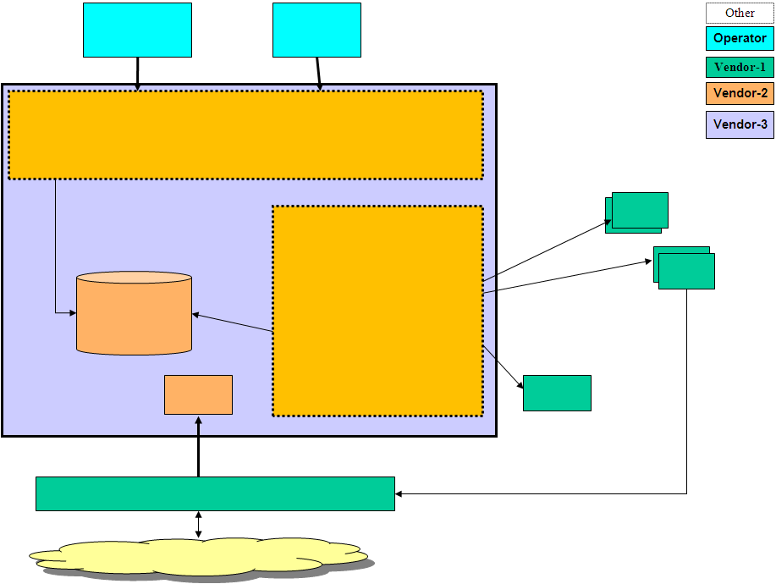
Figure 1: High-Level Architecture

The following sub-sections provide hints and details about the major system domains working harmoniously together as a single system. The aim is to provide a guideline on how the system/solution works by providing the purpose, role and responsibility of system/solution domains. Note that for details of role and responsibility on the modules/applications within a domain, please refer to next section.

[Database Domain Name]

Purpose, role and responsibility, major functionality fulfilled by this domain and a description of this domain from architectural perspective…

[Domain-Name 1]

…. Purpose, role and responsibility, major functionality fulfilled by this domain…

[Domain-Name2]

…. Purpose, role and responsibility, major functionality fulfilled by this domain…

[Domain-Name n]

…. Purpose, role and responsibility, major functionality fulfilled by this domain…

Low Level Architecture

This section provides a lower level overview of the structural and functional decomposition of the actual system modules/applications within related domains. Focus on how and why the system was decomposed in a particular way into such application modules. Include information on the major responsibilities and roles the system applications/modules must play.

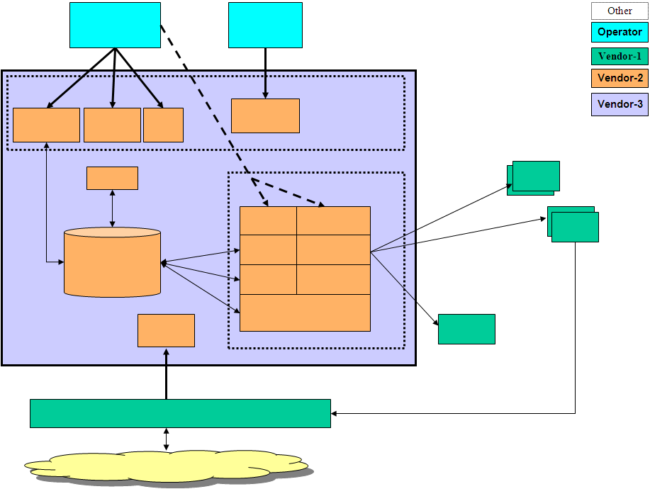
Figure 2: Low-Level Architecture

Application, Component, or Module Name-1

The purpose of this section is to highlight the specific role, responsibility and the main functionality fulfilled by the relevant Application Module within the overall architecture.
Sample:
Module Properties | Property Details
Name | APRMWEB
Module Category  (Application / Library / Other ) | Application
Module Type  (PLSQL / EJB / WebService / Standalone / Library/Web Server) | Web Server
Shipment Type  (JAR / EAR / WAR / BINARY EXE / SCRIPT / (UN)WRAPPED PLSQL) | EAR
Interaction Type  (Synchronous/Asynchronous) | Asynchronous (with web browser on client side)  Synchronous with APRMWS (APRM Web Service)
DB Dependency | NO
Expected Latency | ~50ms
Access Level  (Public / Non-Public / 3rd Party) | Internal
Input | From ZK Update Engine information submitted from relevant web page
Output | TXDR
Main Processing  Logic | APRMWEB is the Model/View and Controller layer developed compliant with ZK framework.  Views are provided as ZUL files.  Model Layer is lightweight and no business logic related model objects are managed in this layer.  Controller is a relay in the sense that each page requests the relevant Back-End Service operation by invoking Execute(TXDR) web service.  TXDR contains all information with regards to requested operation and the payload for that operation.  This provides a message centric approach, and web service layer is only used as a transport layer and does NOT need to be modified for different types of business operations, making web service layer intact from business logic.

Application, Component, or Module Name-2

The purpose of this section is to highlight the specific role, responsibility and the main functionality fulfilled by the relevant Application Module within the overall architecture.
Sample:
Module Properties | Property Details
Name | REQIF
Module Category  (Application / Library / Other ) | Application
Module Type  (PLSQL / EJB / WebService / Standalone / Library) | Standalone
Shipment Type  (JAR / EAR / WAR / BINARY EXE / SCRIPT / (UN)WRAPPED PLSQL) | JAR
Interaction Type  (Synchronous/Asynchronous) | Synchronous
DB Dependency | NO
Expected Latency | ~20ms
Access Level  (Public / Non-Public / 3rd Party) | Public
Input | GDR
Output | GDR
Main Processing  Logic | REQIF is an internal high-throughput (non-public) common low-level Synchronous to Asynchronous Technical GW of APRM.  REQIF decouples the external synchronous web service layer, from the high throughput asynchronous processing sub-system (TMF).  Processing logic is as follows;  - Get GDR and block synchronous RMI REQIF.execute(gdr) call  - Generate INTL_TXN_ID  - Register request to REQUEST_INPUT and REQUEST_INPUT_DETAIL. Set REQUES_INPUT.TXN_STATUS=’R’ indicating request registered.  - MXLIB.WRITE (GDR) to JMS TMF-Q  - MXLIB.commit & DB.COMMIT  - Wait for reply in JMS: MXLIB.READ from REQIF-Q  - Update TXN_REPLIED 'Y' on REQUEST_INPUT  - Find blocked RMI call for the relevant INTL_TXN_ID  - Return back to RMI client  - MXLIB.COMMIT (to DELETE the READ reply message from JMS-Q)  - DB.COMMIT

Interfaces & Integration

This section provides a list and a brief description of the software and communication interfaces supported by the system and/or used by components within the overall system/solution. Note that for the actual specification of each interface; please refer to the relevant interface specification document.

The below diagram provides the IDs of the critical interfaces used by relevant applications/modules within the overall solution/system design. If the integration architecture is quite complex, then, please use related integration architecture templates.

Interfaces and Integration Map

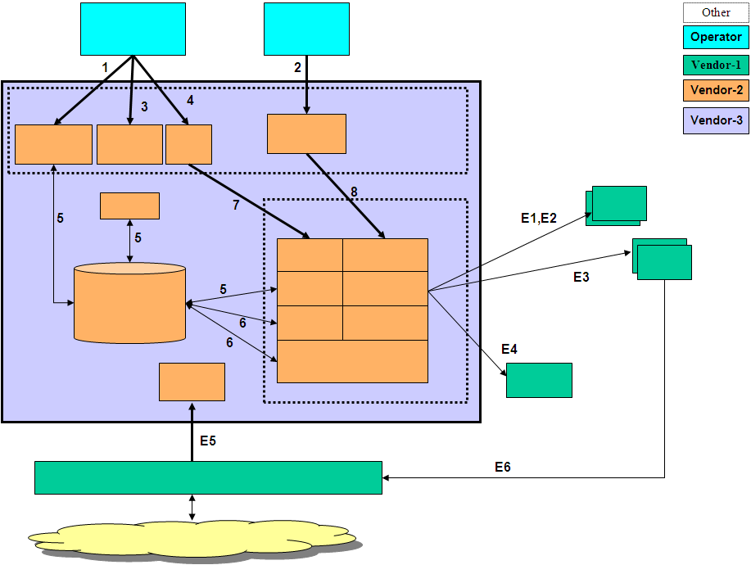
Figure 3: Interfaces and Integration Map

External Interfaces Map
This section provides a list of the interfaces provided by the systems outside the scope of the solution/system of our concern. In other words this section lists the interfaces that are external. For the actual specification of interfaces, please refer to relevant interface specification documents.

ID | Description | Source  Applications/  Modules | Destination  Applications/  Modules | Protocol | Client  Interaction Type | Frequency/  Response | Type | Interface  Packaging | Access  Level
E1 | … | … | … | RPC over TCP | Synchronous | 500ms | Realtime | Java APIs | Public
E2 | … | … | … | Web Service http-soap | Synchronous | <5sec | Online | Java APIs | Public
E3 | … | … | … | File Based  ASN.1 | Asynchronous, | 10 minutes | scheduled batch | N/A | Public
E4
E5
 | … | … | …

System/Solution Interfaces Map
This section provides a list of the publicly accessible and private interfaces provided by the system/solution. Note that since private interfaces are used internal and not supported, only the critical ones can be provided as additional information. For the actual specification of interfaces, please refer to relevant interface specification documents.

ID | Description | Source  Applications/  Modules | Destination  Applications/  Modules | Protocol | Client  Interaction Type | Frequency/  Response | Type | Interface  Packaging | Access  Level
1 | … | … | … | Web Service http-soap | Synchronous | <5sec | Online | Java APIs | Public
2 | … | … | … | Web Service http-soap | Synchronous | <5sec | Online | Java APIs | Public
3 | … | … | … | File Based  ASN.1 | Asynchronous, | 10 minutes | scheduled batch | N/A | Public
4
…
7 | … | … | … | ASCII over TCP | Synchronous | <300ms | Realtime | C shared library | Private

Deliverables Portfolio; Applications and Libraries

This section provides a list of deliverables from deployment perspective where a list of all i2i developed and/or 3rd party application and libraries is to be provided.

i2i developed Applications and Libraries
Name | Description | Module Category  (Application/  Library) | Shipment Type
APRMWEB | View Layer and Basic Controller. Set of ZUL files and basic controller related Java classes on View Layer. | APPLICATION | EAR
APRMWS | APRM Web Service | APPLICATION | EAR
REQIF | Request Interface RMI Gateway | APPLICATION | JAR
TMF | Transaction Mgmt Function | APPLICATION | JAR
INT-E | Integration Engine | APPLICATION | JAR
BACH | Batch Operations Handler | APPLICATION | JAR
GDR.xsd  GDR.jar | Generic Data Record XML Schema Specification | LIBRARY | JAR
TXDR.xsd  TXDR.jar | Transaction Data Record XML Schema Specification | LIBRARY | JAR
ENTITY.xsd  ENTITY.jar | Entity XML Schema Specification that holds all PRM related entity object model; Dealer, Position, User etc. used for transport of all business value objects over Web Service, RMI and JMS layers. | LIBRARY | JAR
CHARSPEC.xsd  CHARSPEC.jar | Screen Objects and characteristics XML Schema Specification | LIBRARY | JAR
I2iCommon.xsd  I2iCommon.jar | Common Value Object types | LIBRARY | JAR
WORKFLOW.xsd  WORKFLOW.jar | Workflow Model XML Schema Specification | LIBRARY | JAR
WFELib  (wfecore.jar and  wfeTMF.jar) | Workflow Library providing workflow API | LIBRARY | JAR
BIZLib.jar | Business Library that provides all DB layer related update logic | LIBRARY | JAR
EFELib.jar | Enterprise Function Evaluator Library that provides a configurable action processing framework used by INT-E and WFELib | LIBRARY | JAR
INT_DSF.jar | DSF Integration Plug-In Functions API functions that implement EFE interfaces | LIBRARY | JAR
INT_INFODEALER.jar | INFODEALER Integration Plug-In Functions API functions that implement EFE interfaces | LIBRARY | JAR
INT_OM.jar | OM Integration Plug-In Functions API functions that implement EFE interfaces | LIBRARY | JAR
INT_BSCS.jar | BSCS Integration Plug-In Functions API functions that implement EFE interfaces | LIBRARY | JAR
INT_MERNIS.jar | MERNIS Integration Plug-In Functions API functions that implement EFE interfaces | LIBRARY | JAR
INT_SAP.jar | SAP Integration Plug-In Functions API functions that implement EFE interfaces | LIBRARY | JAR
INT_LDAP.jar | LDAP Integration Plug-In Functions API functions that implement EFE interfaces | LIBRARY | JAR
INT_LDAP_DEALER.jar | Dealer LDAP Integration Plug-In Functions API functions that implement EFE interfaces | LIBRARY | JAR
MAIL.jar | MAIL sending Plug-In Functions API functions that implement EFE interfaces | LIBRARY | JAR
WFE_FUNC.jar | Other WFE related Plug-In API functions that implement EFE interfaces | LIBRARY | JAR
dtflib.jar  DecisionTreeSchema.jar  DecisionTreeSpecification.jar | Decision Tree Library that allows configurable message routing and determination of workflow transition and selection rules | LIBRARY | JAR
Mxlib.jar | Message Exchange Library for configurable inter-application message routing | LIBRARY | JAR
ithreadpool.jar | Configurable multi-threaded and reliable application framework | LIBRARY | JAR

3rd Party Applications and Libraries
The below table depicts the most critical 3rd party libraries used by the System/Solution. Since versions may change at time of deployment, they are not provided.

Name | Description | Module Category  (Application/  Library) | Shipment Type
Axis.jar | Apache Axis related to web services | LIBRARY | JAR
Commons-xxx.jar | Apache commons libraries;  - Commons-logging  - Commons-cli  - Commons-dbcp  - Commons-dbutils  - Commons-lang  - Commons-pool  - Commons-beanutils | LIBRARY | JAR
Junit.jar | JUnits related JAR | LIBRARY | JAR
Log4j.jar | Logging related JAR | LIBRARY | JAR
Saxon9he.jar  Saxpath.jar | XML processing related JAR | LIBRARY | JAR
Xbean.jar  Xbean.xpath.jar | XML Beans related JAR | LIBRARY | JAR
Pop3.jar  Smtp.jar  Mailapi.jar | Mail related JAR | LIBRARY | JAR
Velocity.jar | Template driven development JAR  Used for email templates and other integration purposes | LIBRARY | JAR
Telnetd.jar  Dsn.jar | TCP/IP based communication JAR | LIBRARY | JAR

Appendix

Document Control

Superseded Documents
- N/A

Change Control & Distribution
Owner | [OWNER NAME]
Reviewer
Approved By
Distribution
File Name | 0000.doc

Version History
Version | Change Descriptions | Author | Date
1.0.0 | Initial Version | [Author Name] | 01/Jan/2014

Approvals
This document requires the following approvals:

Name | Title | Date | Signature | Version

